

NAME: Pratyush Kumar

Query 1: Total number of confirmed cases in different nations?

⇨ We will plot this in world map

⇨ We took world table and placed in on confirmed column section

⇨ We plotted the data on world map with green showing least cases and red showing maximum cases(grey showing no data available).

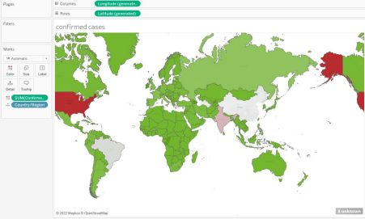

Query 2: Total number of recovered cases in the world.

⇨ We will plot this in world map

⇨ We took world table and placed in on recovered column section.

⇨ We plotted the data on world map with light blue showing least recovered cases and dark blue showing maximum recovered cases(grey showing no data available).

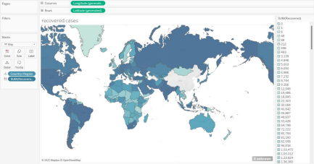

Query 3: Total number of confirmed cases in india.

⇨ We will represent this in bar graph

⇨ First we select country/reigion from table section section along with confirmed section. ⇨ Then put country/region in filters and selection ‘india’ only and plot a bar graph. ⇨ And we put sum(confirmed) in column section and country and state in row section.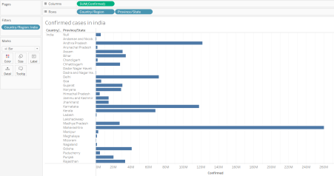

Query 4: Recovery cases in India.

⇨ Select country(dimension) and recovered(measures) and then and then select ‘text tables’ from show me.

⇨ Add country to filters and and select only India

⇨ Add province/state to marks and a table will be formed

⇨ Change show me option to bubble and add recovered to text in marks for number to show and add state in colors for color differentiation

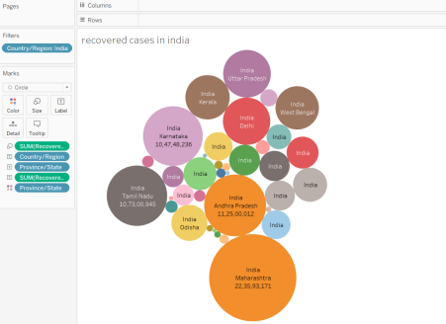

Query 5: Make a trend line prediction for future cases in india

⇨ We will make this in line graph

⇨ Select Last update(dimension) and recovered(measures) and drag them to row and column and rows respectively.

⇨ Open up the last updates in quarters and months

⇨ Add country filter to “INDIA”

⇨ Add Trend from analytics to liner to prediction of line graph.

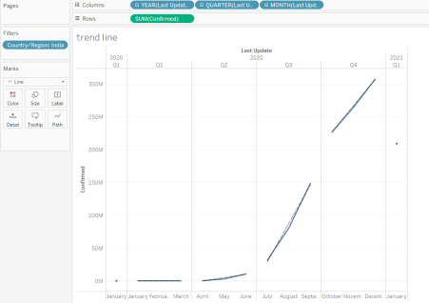

Query 6: Find highest deaths rate at international levels.

⇨ We will plot this in world map

⇨ We took country (dimension) and placed in deaths(measure) section.

⇨ We plotted the data on world map with light red showing least death cases and dark red showing maximum death cases(grey showing no data available).

